Types of Blob Types
→ Click on the upload option

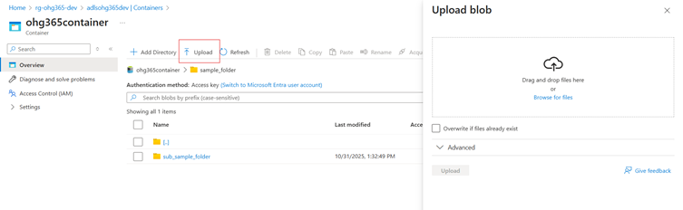

Once you click the Upload option, the Browse for Files page will appear. At the bottom of that page, select the Advanced dropdown option.
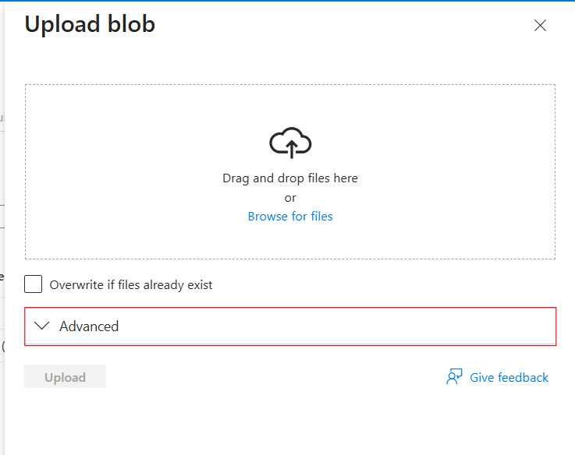

After clicking the Advanced dropdown option, the Blob Types will appear. Select the blob type you want from the list.

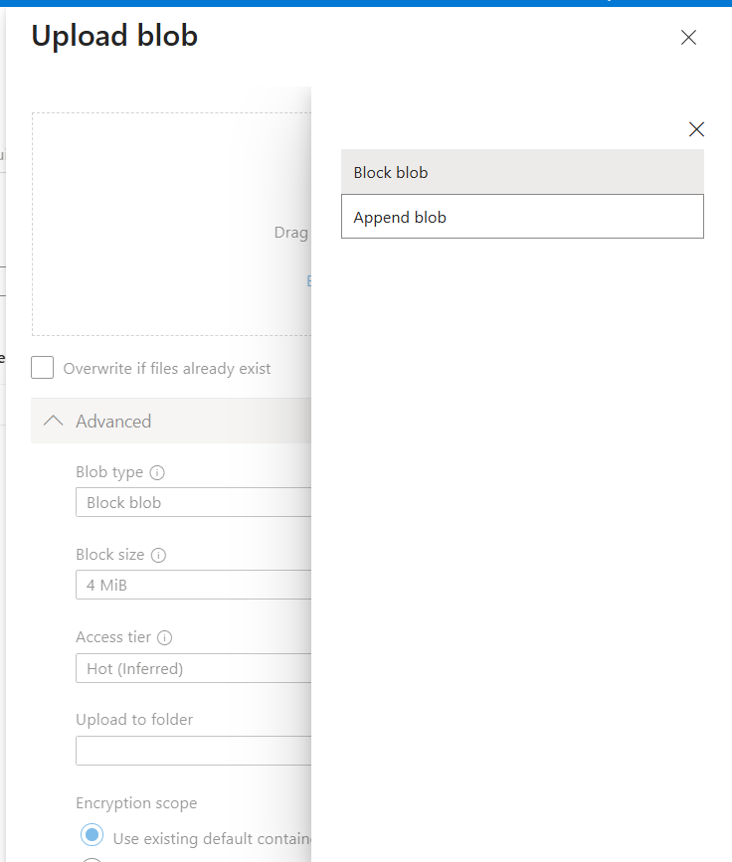
After selecting the blob type, all items will be displayed on the Overview page.
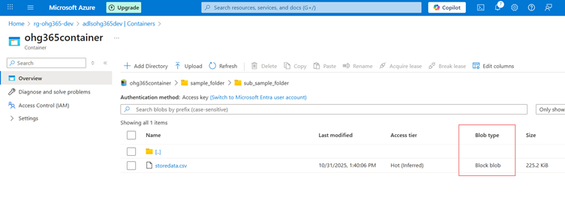

Blob Type | Best For | Example Use
Block Blob | Storing text or binary data | Images, videos, documents, CSV files
Append Blob | Data that is constantly appended (append-only) | Logs, telemetry, audit data

1. Block Blob
Most common blob type used in Azure.
What it is:
- Stores text and binary data (files like .txt, .jpg, .mp4, .csv, etc.)
- Data is split into blocks, and each block is identified by a block ID.
- You can upload or update blocks individually and commit them together.
Use Cases:
- Storing images, videos, PDFs, and backups.
- Data files for analytics (CSV, JSON, Parquet).
- Large files uploaded in chunks.
Example:
You upload a 500 MB video file — Azure divides it into smaller blocks and uploads each part separately for speed and reliability.

2. Append Blob
Special type of blob for data that grows over time.
What it is:
- Optimized for append operations — you can only add new data to the end, not modify or delete existing data.
- Each time you add new information, it’s appended to the blob.
Use Cases:
- Storing log files.
- Application telemetry or diagnostics data.
- Streaming data that’s constantly being added.
Example:
You’re logging website visits. Each time a new visitor arrives, their data (timestamp, IP, etc.) is appended to the existing log file.

Blob Type | Structure | Read/Write Behavior | Common Use
Block Blob | Data stored as blocks | Upload or replace blocks | Files, media, documents
Append Blob | Sequentially added blocks | Append-only | Logs, telemetry, streaming data

